Chapter 9, Problem 25.

Using phasors, determine i(t) in the following equations:

- 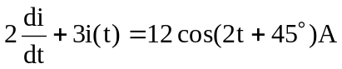
- 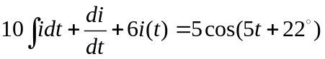A

